**How to Create an AMI for Amazon EBS Backed Instances**

This demonstrates how to create an Amazon EBS-backed AMI from a running Amazon EBS-backed instance.

1. Go to the AWS console through the URL [http://aws.amazon.com/console.](http://aws.amazon.com/console) Select the EC2 service. From the EC2 dashboard, click on the Running Instances or the Instance link.

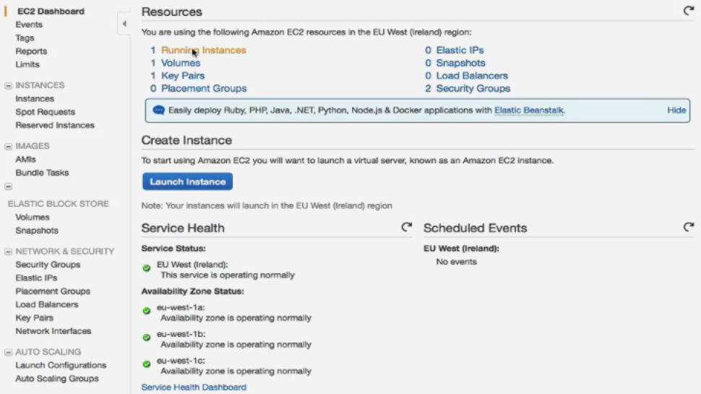

1. Select the EBS backed running instance. Mostly all the Amazon ami have EBS Volume or [launch an EBS backed instance.](http://www.newvem.com/how-to-launch-an-amazon-aws-ec2-instance/)

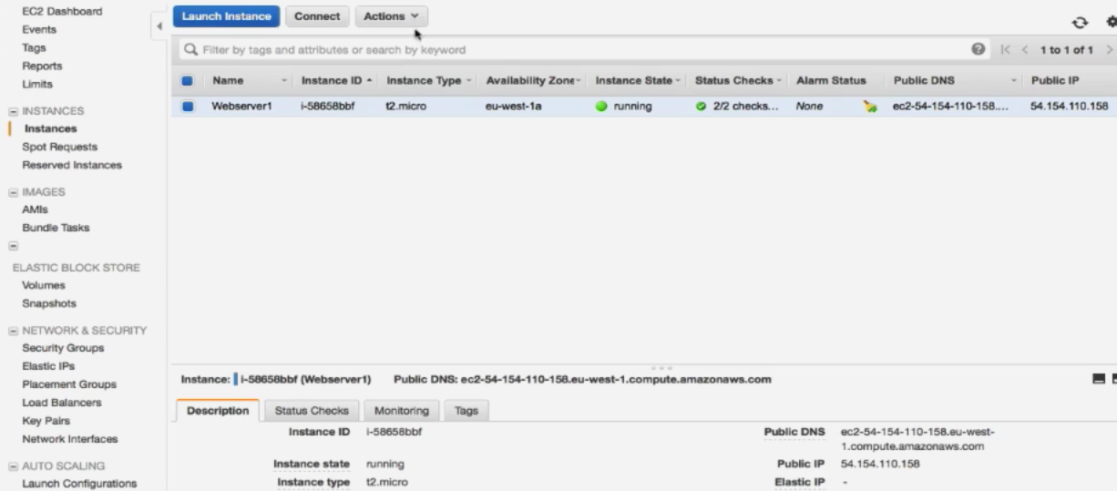

1. An AMI serves as the basic unit of deployment for services delivered using EC2. Thus, when the user launches an instance from an AMI, it will have all the software installed or available data of the current running instance.
2. Configure the instance with any random data / install some software or create some temporary files or directories, as shown below.

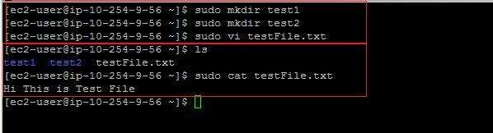

1. Select the instance and click on the “Actions” menu, as shown in step#2. Click on “Create Image (EBS AMI)”.

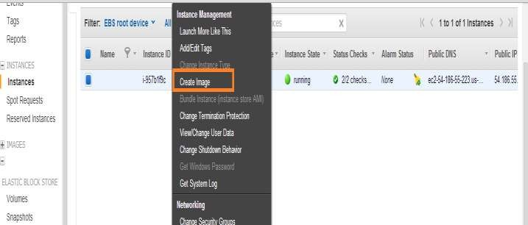

1. The AMI creation wizard will ask for the AMI name, description, and the other required parameters. Provide details, such as the AMI Name, and AMI description.
   1. By default when the AMI is created, EC2 shuts down the instance. Next, it takes the snapshots of any attached volumes and finally creates and registers the AMI. After this, EC2 reboots the instance. The instance may not respond or be available temporarily during this process. Select the option “No Reboot” if the user does not want to reboot the instance. If the “No Reboot” option is selected, then AWS does not guarantee the file system integrity of the created image.
   2. The user can also modify the root volume. Select the root volume tab. The user can modify the volume size or volume type. Click on “Save” to save the changes made on the root volume.

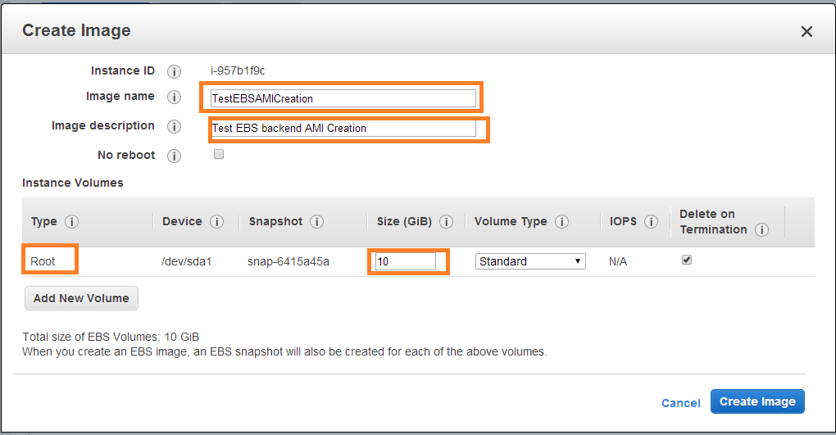

1. To add an additional EBS volume while launching an instance, configure it by using the EBS Volumes tab. First select the EBS Volumes tab.

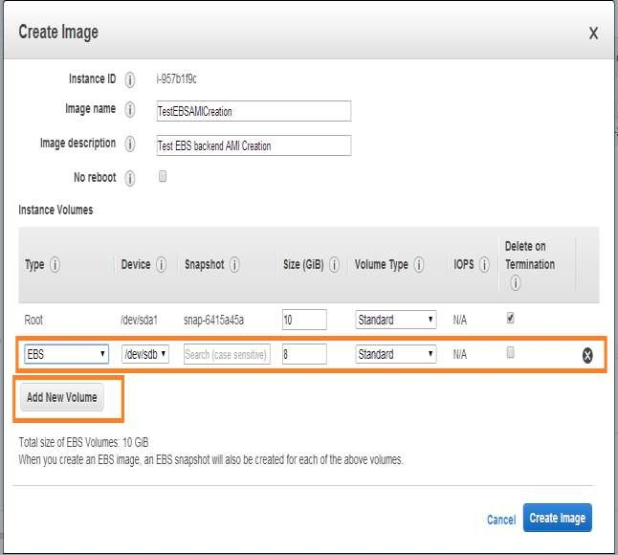

1. Fill in details, such as the Device, Snapshot, Size and Volume type and click on the Add button. When an AMI is configured with an additional EBS volume, and an instance is launched with this new AMI, the additional volumes are automatically attached to the instance

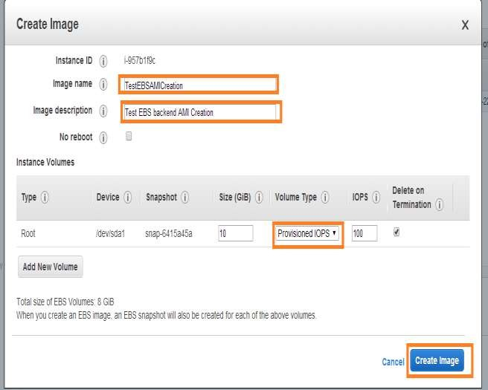

1. To add an instance store volume, click on Instance Store Volumes, select the Instance Store and Device, and click on Add. When the user launches an instance from the new AMI, the additional volumes are automatically initialized and mounted. The data in an instance store volume is not persistent. Thus, it must be used only for temporary data storage. This option is available for all the instance types except the micro instance.

Click on the “Create Image” button after configuring all the parameters.

1. AWS will provide a confirmation about the AMI creation request. It provides the AMI ID. Click on the “View pending image ami-..” link or close button.

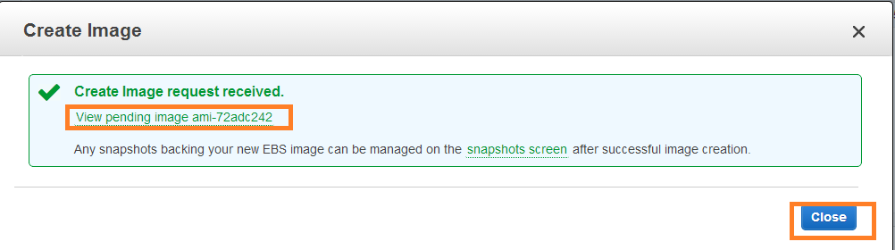

1. The View pending image link will take the user to the AMI console. It displays that the AMI creation is in progress.

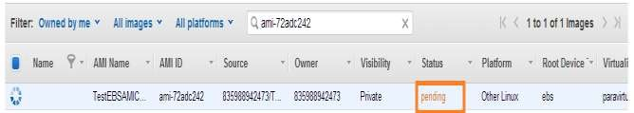

1. Once the AMI has been created, it will be in an available state.

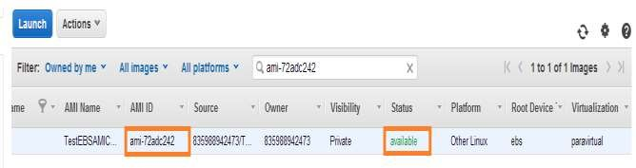

1. If a [new instance is launched from this AMI,](http://www.newvem.com/how-to-launch-an-amazon-aws-ec2-instance/) it will show the output as given below. The reason for the additional volumes or the ephermal storage is because the user configured it.

